* 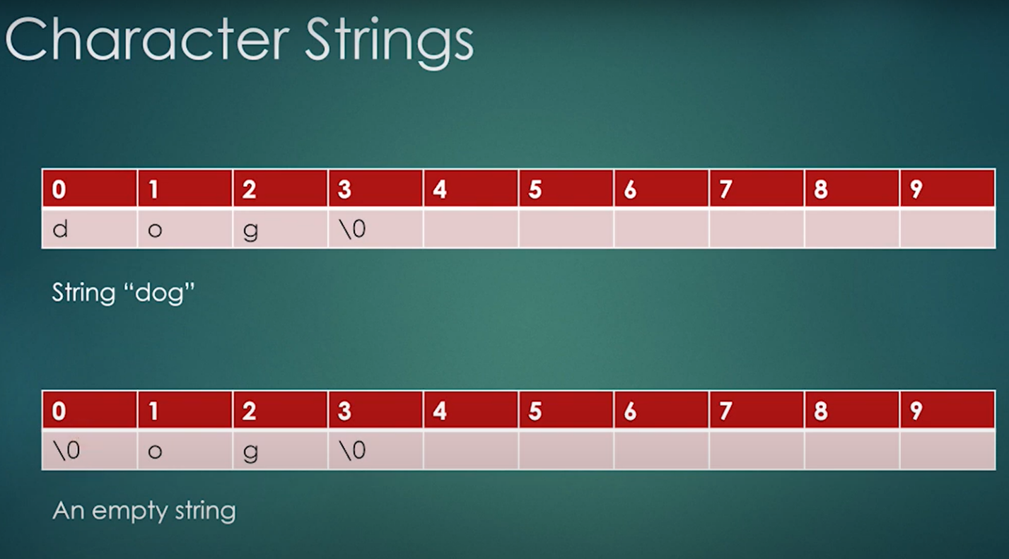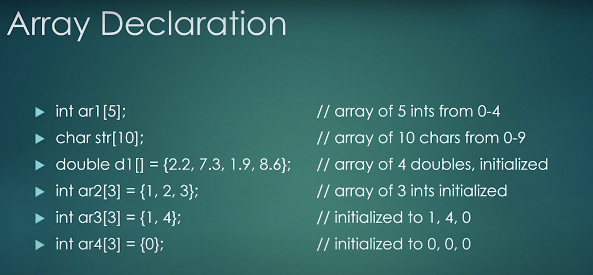\0 is called a string terminator.
* Specifier **NAME[].** The name of the array is with the [].
* Array numbers always starts with 0,1,2…